Type the title of your paper here
List the author names here^{1*}, List the author names here²
¹ Type the author affiliation here
² Type the author affiliation here
Type the corresponding author’s e-mail address here
Abstract. Start your abstract here…
- Introduction
The first paragraph after a heading is not indented (Bodytext style).
Other paragraphs are indented (BodytextIndented style).
- Method
The first paragraph after a heading is not indented (Bodytext style).
Other paragraphs are indented (BodytextIndented style).
- Result and Discussion
The first paragraph after a heading is not indented (Bodytext style).
Other paragraphs are indented (BodytextIndented style).

A subsection
The first paragraph after a heading is not indented (Bodytext style).
Other paragraphs are indented (BodytextIndented style).
    - A subsubsection. The paragraph text follows on from the subsubsection heading but should not be in italic.
- Conclusion
The first paragraph after a heading is not indented (Bodytext style).
Other paragraphs are indented (BodytextIndented style).
- Acknowledgement
The first paragraph after a heading is not indented (Bodytext style).
Other paragraphs are indented (BodytextIndented style).
References
- A reference
This reference has two entries but the second one is not numbered (it uses the ‘Reference (no number)’ style.
- Another reference
- More references

Contoh menampilkan gambar:
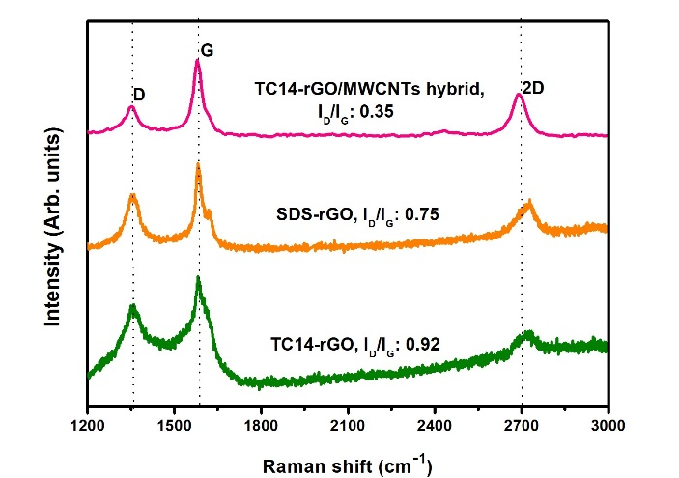
Figure 1. Micro-Raman spectra of TC14-rGO, SDS-rGO and TC14-rGO/MWCNTs hybrid thin films

Contoh menampilkan tabel:

Table 1. Micro-Raman analysis results of TC14-rGO, SDS-rGO and TC14-rGO/MWCNTs hybrid thin films
Sample | D-peak (cm⁻¹) | G-peak (cm⁻¹) | I_{D}/I_{G} ratio | 2D-peak (cm⁻¹)
TC14-rGO | 1368 | 1590 | 0.92 | 2766
SDS-rGO | 1355 | 1587 | 0.75 | 2716
TC14-rGO/MWCNTs hybrid | 1352 | 1581 | 0.35 | 2690

Keterangan:
Introduction
Uraikan latar belakang dan permasalahan yang akan diteliti, apa yang sudah dilakukan peneliti-peneliti sebelumnya (state of the art) secara ringkas, dan diakhiri dengan tujuan penelitian

Metode
Ceritakan bagaimana penelitian ini dilakukan, mulai dari menggunakan alat telusur literature apa, keywords, kriteria inklusi, dan cara menghasilkan sintesis (analisis data)

